TITLE OF PROJECT REPORT
Project Hangout

A PROJECT REPORT

Submitted by

NAME OF THE CANDIDATES
(Register No)
Vedant Kutmate [20BCE10491]
Harsh Vardhan Singh [20BCE10368]
Vedish Kabara [20BCE10407]
Pooja Kumari [20BCE10543]
Aayush Yadav [20BCE10401]

in partial fulfillment for the award of the degree
of

BACHELOR OF TECHNOLOGY

in
PROGRAM OF STUDY
Computer Science and Engineering



SCHOOL OF COMPUTING SCIENCE AND ENGINEERING
VIT BHOPAL UNIVERSITY
KOTHRIKALAN, SEHORE
MADHYA PRADESH - 466114

December,2021

A PROPOSED DESIGN AND IMPLEMENTATION OF
PROJECT HANGOUT
A PROJECT REPORT

Submitted by

Vedant Kutmate [20BCE10491]
Harsh Vardhan Singh [20BCE10368]
Vedish Kabara [20BCE10407]
Pooja Kumari [20BCE10543]
Aayush Yadav [20BCE10401]

in partial fulfillment for the award of the degree
of

BACHELOR OF TECHNOLOGY

in

COMPUTER SCIENCE AND ENGINEERING

SCHOOL OF COMPUTING SCIENCE AND ENGINEERING
VIT BHOPAL UNIVERSITY
KOTHRIKALAN, SEHORE
MADHYA PRADESH - 466114

NOV 2021

VIT BHOPAL UNIVERSITY, KOTHRIKALAN, SEHORE
MADHYA PRADESH – 466114

BONAFIDE CERTIFICATE

Certified that this project report titled “PROJECT HANGOUT” is the bonafide work of “
Vedant Kutmate [20BCE10491]
Harsh Vardhan Singh [20BCE10368]
Vedish Kabara [20BCE10407]
Pooja Kumari [20BCE10543]
Aayush Yadav [20BCE10401]
…” who carried out the project work under my supervision. Certified further that to the best of my knowledge the work reported at this time does not form part of any other project/research work based on which a degree or award was conferred on an earlier occasion on this or any other candidate.

PROGRAM CHAIR PROJECT GUIDE
Sandip Mal Aashish Kumar Sahu
School of Computer Science and Engineering School of Computer Science and Engineering
VIT BHOPAL UNIVERSITY VIT BHOPAL UNIVERSITY

The Project Exhibition I Examination is held on _______________

ACKNOWLEDGEMENT

First and foremost I would like to thank the Lord Almighty for His presence and immense blessings throughout the project work.
I wish to express my heartfelt gratitude to Dr. S. Poonkuntran, Head of Department, School of Computer Science for much of his valuable support encouragement in carrying out this work.
I would like to thank my internal guide Mr.____Aashish_Kumar Sahu________,for continually guiding and actively participating in my project, giving valuable suggestions to complete the project work.
I would like to thank all the technical and teaching staff of the School of Computer Science, who extended directly or indirectly all support.
Last, but not least, I am deeply indebted to my parents who have been the greatest support while I worked day and night for the project to make it a success.

LIST OF ABBREVIATIONS

1] IA – Information Architecture

2]WFMB- Wire frame and Mood Board

3]UX- User Experience

LIST OF FIGURES AND GRAPHS

FIGURE NO. | TITLE | PAGE NO.
1] | User journey map | 7
2] | Information architecture | 9
3] | Site map | 12

ABSTRACT
Project Hangout is an app that lets you host live audio- only conversations with a group of people, while other users can join and listen in. The topics can range from tech to sports, business, sales and marketing, literature, parenting, and so on. You can also randomly host your own space and people turn up magically and the interactions may last for hours. Project Hangout lets you interact with people all around the world from different communities and clubs, share your own thoughts with just a click of a button. One of the best features of Hangout is that anyone can host their own room, public or private, making the app suitable for an intimate chat with a few friends or for public debate.
We were looking for an amazing idea which would be a new way to connect people. LinkedIn was revolutionary but the next thing is Audio Only Conversations. Few months back Discord launched Discord Discovery Stages to deliver this issue of just text conversations. But the feature has too problems in it. First of all, Discord is not easy to use. its onboarding is too difficult for the First-time users. Recently Discord shut down this feature due the lack of response. But we thought this was a really cool idea for heading conversations. This motivated us to enhance this feature with our own idea and make a prototype out of it.

TABLE OF CONTENTS
CHAPTER NO. | TITLE | PAGE NO.
 | List of Abbreviations  List of Figures and Graphs  List of Tables  Abstract | iii  iv  v  vi
1 | CHAPTER-1:  PROJECT DESCRIPTION AND OUTLINE  Introduction  1.2 Motivation for the work  1.3 [About Introduction to the project  including techniques]  1.4 Problem Statement  1.5 Objective of the work  1.6 Summary | 1  .  .  .
2 | CHAPTER-2:  RELATED WORK INVESTIGATION  2.1 Introduction  2.2 <Core area of the project>  2.3 Existing Approaches/Methods  2.3.1 Approaches/Methods -1  2.3.2 Approaches/Methods -2  2.3.3 Approaches/Methods -3  2.4 <Pros and cons of the stated Approaches/Methods >  2.5 Issues/observations from investigation  2.6 Summary
3 | CHAPTER-3:  REQUIREMENT ARTIFACTS  3.1 Introduction  3.2 Hardware and Software requirements  3.3 Specific Project requirements  3.3.1 Data requirement  3.3.2 Functions requirement  3.3.3 Performance and security requirement  3.3.4 Look and Feel Requirements  3.3.5 ………  3.4 Summary
4 | CHAPTER-4:  DESIGN METHODOLOGY AND ITS NOVELTY  4.1 Methodology and goal  4.2 Functional modules design and analysis  4.3 Software Architectural designs  4.4 Subsystem services  4.5 User Interface designs  4.5 ………………..  4.6 Summary
5 | CHAPTER-5:  TECHNICAL IMPLEMENTATION & ANALYSIS  5.1 Outline  5.2 Technical coding and code solutions  5.3 Working Layout of Forms  5.4 Prototype submission  5.5 Test and validation  5.6 Performance Analysis(Graphs/Charts)  5.7 Summary
6 | CHAPTER-6:  PROJECT OUTCOME AND APPLICABILITY  6.1 Outline  6.2 key implementations outlines of the System  6.3 Significant project outcomes  6.4 Project applicability on Real-world applications  6.4 Inference
7 | CHAPTER-7:  CONCLUSIONS AND RECOMMENDATION  7.1 Outline  7.2 Limitation/Constraints of the System  7.3 Future Enhancements  7.4 Inference

Appendix A

Appendix B

References

Note: List of References should be written as per IEEE/Springer reference format. (Specimen attached)

CHAPTER-1: PROJECT DESCRIPTION AND OUTLINE

  - Introduction:
Project Hangout is an app that lets you host live audio- only conversations with a group of people, while other users can join and listen in. The topics can range from tech to sports, business, sales and marketing, literature, parenting, and so on. You can also randomly host your own space and people turn up magically and the interactions may last for hours. Project Hangout lets you interact with people all around the world from different communities and clubs, share your own thoughts with just a click of a button. One of the best features of Hangout is that anyone can host their own room, public or private, making the app suitable for an intimate chat with a few friends or for public debate.
  - Motivation for the Project:
We were looking for an amazing idea which would be a new way to connect people. LinkedIn was revolutionary but the next thing is Audio Only Conversations. Few months back Discord launched Discord Discovery Stages to deliver this issue of just text conversations. But the feature has too problems in it. First of all, Discord is not easy to use. its onboarding is too difficult for the First-time users. Recently Discord shut down this feature due the lack of response. But we thought this was a really cool idea for heading conversations. This motivated us to enhance this feature with our own idea and make a prototype out of it.
  - About Introduction to the project including techniques:
As discussing within ourselves we decided that we will design the app keeping user needs in mind and then hosting the design prototype online and asking users about their views on idea and taking their responses so we can iterate on our designs. For this we followed the whole UX Design process like Empathize, Define, Ideate, Prototype and Test. We did research around the topic about HOW THE WORLD IS SOON GOING TO ADAPT PODCAST? or HOW PODCASTS ARE BOOMING AND THEY ARE THE FUTURE? Keeping these things in mind we did user research and collected what people needs to improve their journey.

  - Problem Statement:
Design a social audio app for the normal productive user or a user who needs to get started with content creation.
  - Objective of the Project:
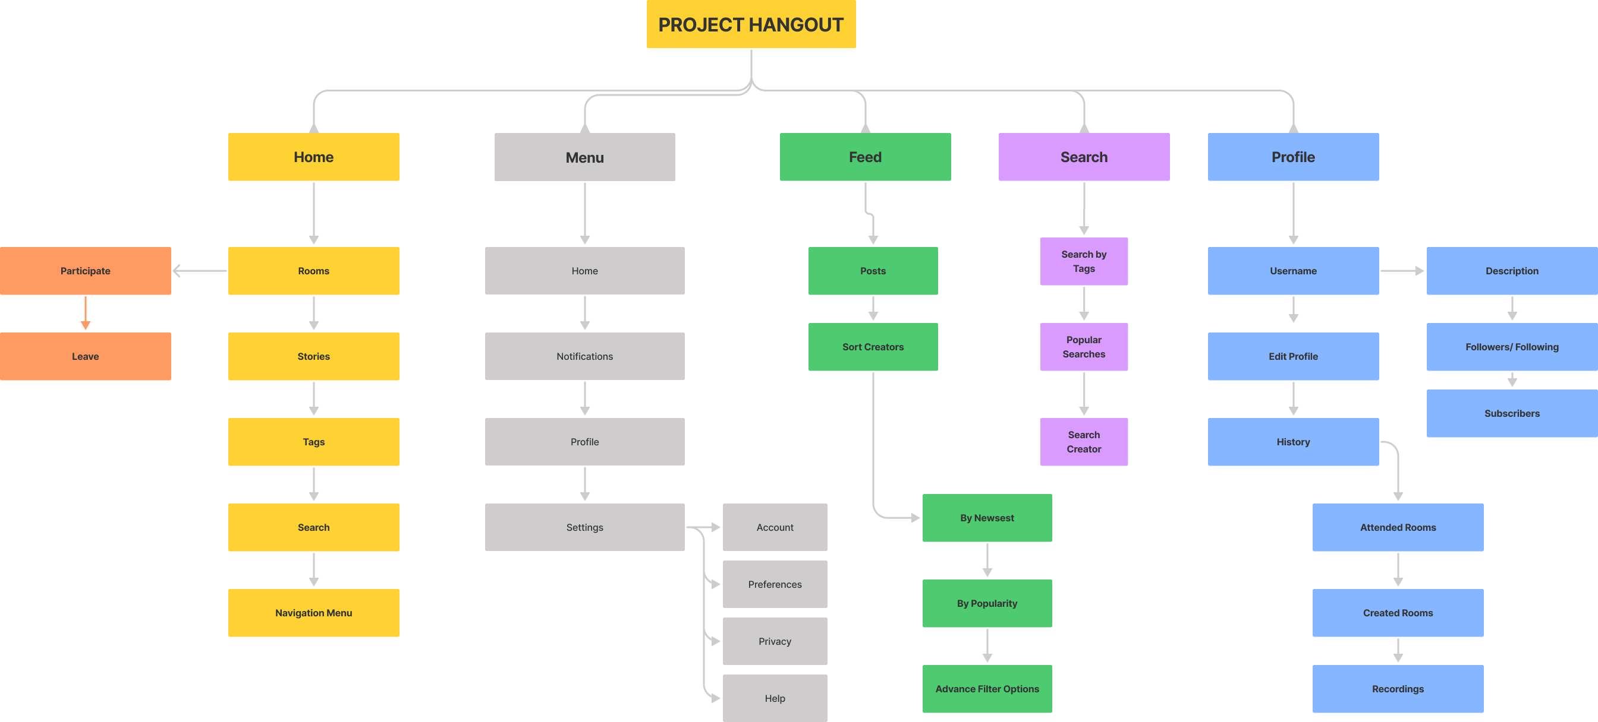
As Spotify’s catalog tops one million podcasts and Twitter buys Breaker, it’s clear that the podcasting wars are just heating up. More than 75 million Indians have listened to a podcast in the past year, with 24% of listeners tuning in weekly. Major tech giants like Apple investing in Apple Music podcast portfolios. Amazon buying “Wondery” a podcasting platform it’s clear that podcasting is going to be the next big thing or content creators. We all know Podcast is a one-way conversation or you can say storytelling, But What If The listener wants to tell his ideas or thoughts or ask his or her doubts then. There is no such feature to do so. People will enjoy and relate more when they will go deep into the conversation.

  - Summery:
So, we ended up deciding that we are going to design a prototype of a Social Audio App keeping it user-centered and by following the UX procedure and also hosting the design of the prototype online so we can gather the end user responses to iterate on those ideas. For that we made an introductory website which tells people about the app the people behind this and also the prototype.

CHAPTER-2: RELATED WORK INVESTIGATION

2.1 Introduction:
In this chapter we will have a look on what kind of research we did on our project to get ourselves familiar with the idea how we broadened our knowledge how we tested the current Discord Stage and discuss the positives and negative of the app.

2.2 Core area of the project:
The project comes under Designing and Front- End Development as we need to design a prototype of Hangout and make the prototype live on our introductory website for which we used HTML and CSS and for designing process referred to User- Centered Design Techniques.
2.3 Existing Approaches/Methods:
2.3.1 Approaches/Methods -1:
Discord Discovery Stages:
When we were looking for the ideas and we used Discord to commence out meetings and having fun we also ended up finding this feature of Discord named Discovery Stages where people can have audio only conversations and it was fun listening to people their thoughts and their perspectives over certain things and it was a nicer way of communication in this pandemic. We saw some panel members discussing on certain topics and they were the experts in their respective fields so it was nice to hear from them.

2.4 Pros and cons of the stated Approaches/Methods:
The real issues with this idea are with people. We don’t know what kind of people can we get to see in these sessions. The content may not be suitable for some age groups or the session can be filled with filthy content and no one can stop them that’s their perspective. One has to leave their stage to not hear such things. Discord should let users know if the session is suitable for respective age groups or not. But also, it is helpful when you want to interact with a person who can guide you and become your mentor. Such healthy conversations can make you feel energetic and motivates you to be productive.
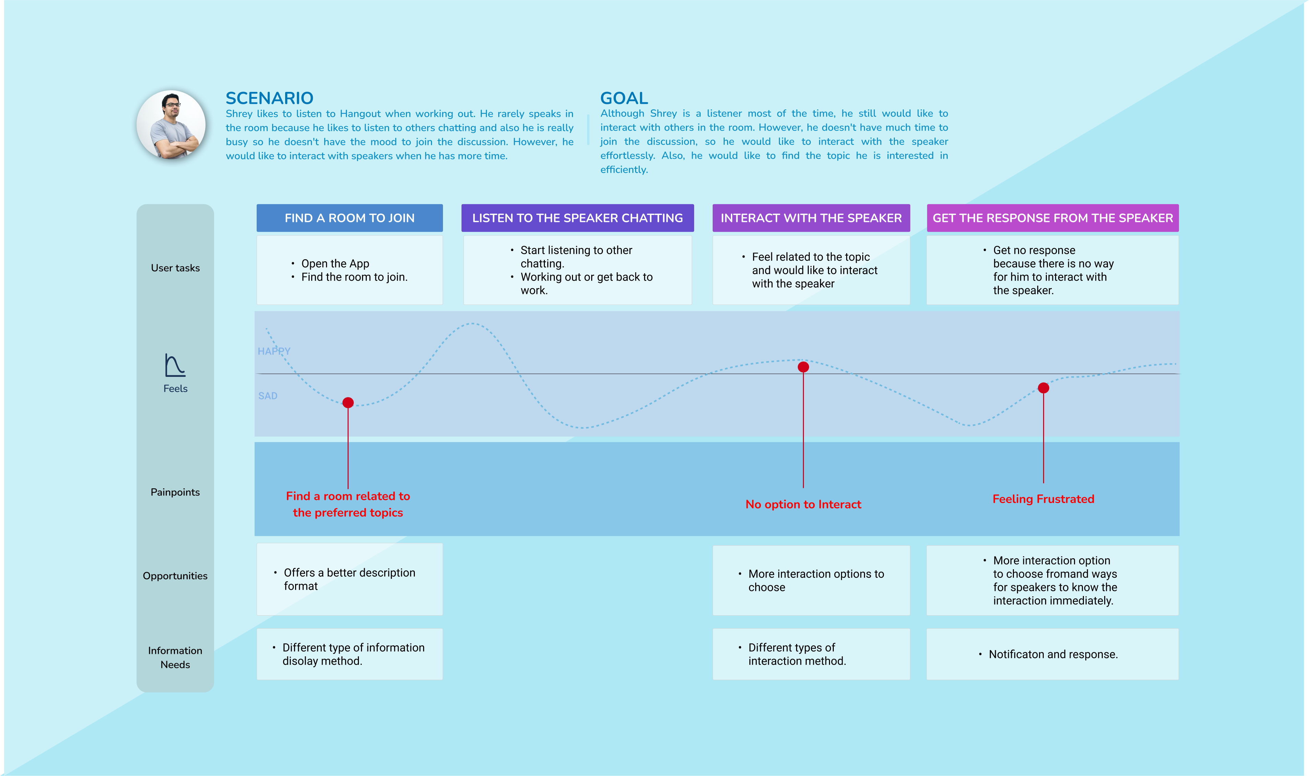

2.5 Issues/observations from investigation:
We observed that having audio only conversation can be a great way to connect with people in a good way for a better cause. Also, such conversation come up with their own issues as all the conversations are not meant to be publicly spoken and tach companies should avoid such behaviors from their users and should implement rules and guidelines for the same.

2.6 Summary:
Over this chapter we looked at the existing work related to our project and thoroughly examined the ins and outs of the product Discovery Stages and looked at the potential of the idea behind it some possible consequences and their pros and cons and issue with the ideas. Even though the idea has great potential but it should be taken forward with care and responsibility.

CHAPTER-3: REQUIREMENT ARTIFACTS

3.1 Introduction:
Until now we had a look on the introduction to our idea behind making the prototype of the app named Project Hangout and all the research which we did while we were exploring the idea and looking how we can improve them from users’ point of view. The idea has great potential if taken forward with care and responsibility. Now let’s have a look at what were the tools which were required for making this project.

3.2 Hardware and Software requirements:
Since our project contains Designing, Prototyping, building a website We need tools to do that. We are going to be using Figma extensively for designing User Interface of the App and the Website, to create mood boards, color and spacing systems and typography. The hardware requirement for the same is as follows. Thanks to Notion being the best note taking tool. We are going to keep our ideas, plans locked in Notion related to our Project. Notion allows limited projects as free to users. You need to take their Pro version to access all their features. Then we need Visual Studio Code i.e., a code editor where we can write HTML and CSS codes for building websites. One can use any other text editor like Sublime Text, Atom, etc. Framer a prototyping tool is an essential part of our project to bring life to our Designs. It's a webapp and it also requires pro version to access all of its features. Lastly, we use Whimsical to draw empathy maps, Wireframes, Mind maps, Sitemaps, User Journey maps, etc.
3.3 Specific Project requirements:
3.3.1 Data requirement:
As Project Hangout is a Social Audio App so the data of the users would be required to show on their profile and to show analytics to the users. We all know how important data is now-a-days so if the product goes into development, then we would ensure all the data of our users will be safe with us.
3.3.2 Functions requirement:
Even though it is an audio app but we want to give users the accessibility to text message feature so they can contact when they are not in any sessions. Also, a recording feature so that the users can see them after a while and can regather the thoughts outspoken in those sessions. Also, the ability to hosts of the session to publish their sessions as podcasts on Spotify and Apple Music and other major podcasting services.
3.3.3 Performance and security requirement:
Project Hangout bot only allows you to join other rooms but you can also host your own room and can get started as a content creator. We also have plans of donations where listeners can donate something to their favourite creator whom they enjoy listening to with their own will. For this we need security policies as users’ money is on the line so we need to make this safer and smoother for both the sender and receiver of the amount. Also, we will be assigning the tags about age limits to let users know which room is suitable for them.
3.3.4 Look & Feel requirement:
As the world is evolving at faster ace and mobile phone are the most used gadgets so it is a necessity that users should enjoy their journey while using their app. Otherwise the users will not accept the idea even though the idea is really good. We ensure that all the journey that users need to do in app are all sorted and we made the user journey maps for the same.
3.4 Summary:
In this chapter we saw what are the tools required to accomplish with our goal. The Data requirement the function requirements the look and feel of the app and performance and security requirements of Project Hangout in order to make sure users feel convenient and safe while using our product.

CHAPTER-4: DESIGN METHODOLOGY AND ITS NOVELTY

4.1 Methodology and Goal:
We conducted User Research/ User Persona and Empathy Mapping. Next, we had some Ideation/ Brainstorming Sessions. Then we drew User Journey Scenarios/ Information Architecture /Sitemaps/ Mood boards. After drawing wireframes, we created User Interface Design and Prototyping and during all this process we simultaneously worked on our website which we made for user testing of our prototype.
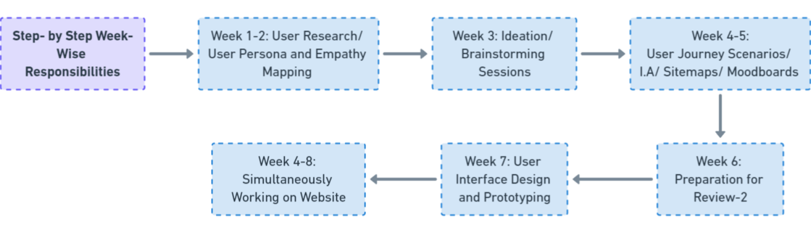

4.2 Functional modules design and analysis:
We took inspiration for the designs of our functional modules from Dribble, Behance, Mobbin Design and many other platforms. We had to constantly look for the consistency throughout our app and website design. So, we created a color system, typography for the same and spacing system for entire Project Hangout and its website so that we can achieve the consistency and the users won’t feel like using different apps every other screen and make them confuse.

4.3 Software Architectural designs:
An architectural diagram is a diagram of a system that is used to abstract the overall outline of the software system and the relationships, constraints, and boundaries between components. It is an important tool as it provides an overall view of the physical deployment of the software system and its evolution roadmap. So, we ended up with our designs to achieve our goals.

4.4 Subsystem services:
There are no sub-system services used in out project as we were only doing the Front-End Development of our website and making the prototype of Hangout for user testing and not going into actual App Development.

4.5 User Interface Designs:
User Interface is a constant Iteration process as the technology is changing at a rapid pace and people do get bored by seeing the same old stuff. Though the UI design of Hangout will keep changing in future but the current User Interface is as follow:
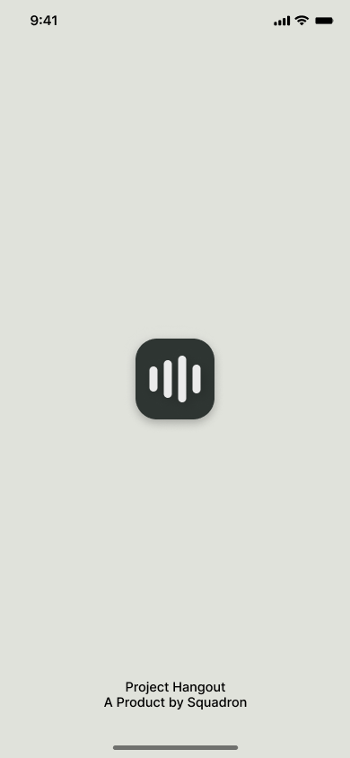

4.6 Summary:
We saw Design methodology and its novelty in this chapter we saw Functional modules design and analysis, Software Architectural designs, Subsystem services and User Interface designs of Project Hangout.

CHAPTER-5: TECHNICAL IMPLEMENTATION & ANALYSIS

5.1 Outline:
As a part of Technical Implementation, we decided to make a website where people can use our prototype and can give their thoughts on the design and the prototype of Project Hangout. We introduced our app our team and our prototype for the users to interact with.

5.2 Technical coding and code solutions:
As coding part is concerned the structure of the website is written in HTML and the website is designed using CSS. For this we used VS Code which is an IDE. We made the design of our website first and then tried to implement it. We faced a lot of issues making it look the way we wanted.

CHAPTER-6: PROJECT OUTCOME AND APPLICABILITY

6.1 Outline:
Project Hangout is an idea to make people come closer again during this pandemic. People can have normal conversations on wide range of topics and can present their view and get other users views on the same topic. Users can even get started with their own original content and can start earning as a creator.

6.2 Key implementations outline of the System:
It’s like a live podcast where you can participate with the host. You can use Hangout house-party to create podcast-related communities without having to add a lot of content production and overhead to keep the audience between episodes engaged, once the application is public. We have named groups or clubs as house-party. While it takes time to create networks and consult experts, imagine the importance of learning on a regular basis from other startups, small business founders, multimillion-dollar CEOs, and tech giants! This platform makes it possible to share a stage, ask a direct question, and receive a real-time answer from experts. We thought of adding a newer perspective in pandemic and idea behind Hangout proves to be an invaluable way to continue to meet new people and gain new perspectives in a time when we can’t meet in person. Hangout is like any other social media app where you can grow as a creator on professional level by hosting house parties and giving quality content to people. We also have plans of adding monetization as it is important that every deserving creator should be rewarded.

6.3 Significant project outcomes:
As said earlier the idea behind a social audio app has potential if guided in a right way. The users could achieve as they can connect with people, can start earning by sharing original content and by hosting their own podcasts. The users can find a newer perspective to connect rather than connecting through chats and commenting on others profile and even not getting replied back.

6.4 Project applicability on Real-world applications:

What can Hangout be used for? Not every entrepreneur is lucky enough to have a mentor they meet and connect with in person. Hangout offers a great platform for connecting with people who will challenge you, inspire you and hold you accountable. The ability to get expert advice is a huge asset when you’re growing a business, and sharing your expertise with others can give even seasoned business owners fresh perspectives. Mentoring benefits both parties, and Hangout is a great way to connect with people and establish mentoring relationships. Next is feedback. Most entrepreneurs or students we know are constantly generating new ideas. Some of these ideas are great. Others are terrible. Most are somewhere in between. One of the great benefits of Hangout is that you’ll have a network with whom you can kick around ideas. Having people in your industry
provide instant input can help you refine your ideas in real-time. Then there is Networking, the most obvious benefit of Hangout is connecting with more people in your industry. Insider insight is valuable in countless ways – spotting and discussing trends, broadening perspectives, and benefiting from shared wisdom. By listening to and participating in events, you’ll expand your network. In addition to Business-to-business networking, you can also use the Hangout platform to engage with potential customers by conducting virtual events. Your retail specialty shoe store could promote a live conversation with the designer of a new athletic shoe, in which customers could get answers and insight into the shoe designing process. Your accounting business could host an event about little-known tax deductions that can save clients’ money. An online seed vendor could have a weekly Q&A with a master gardener. The potential for customer engagement is absolutely enormous.

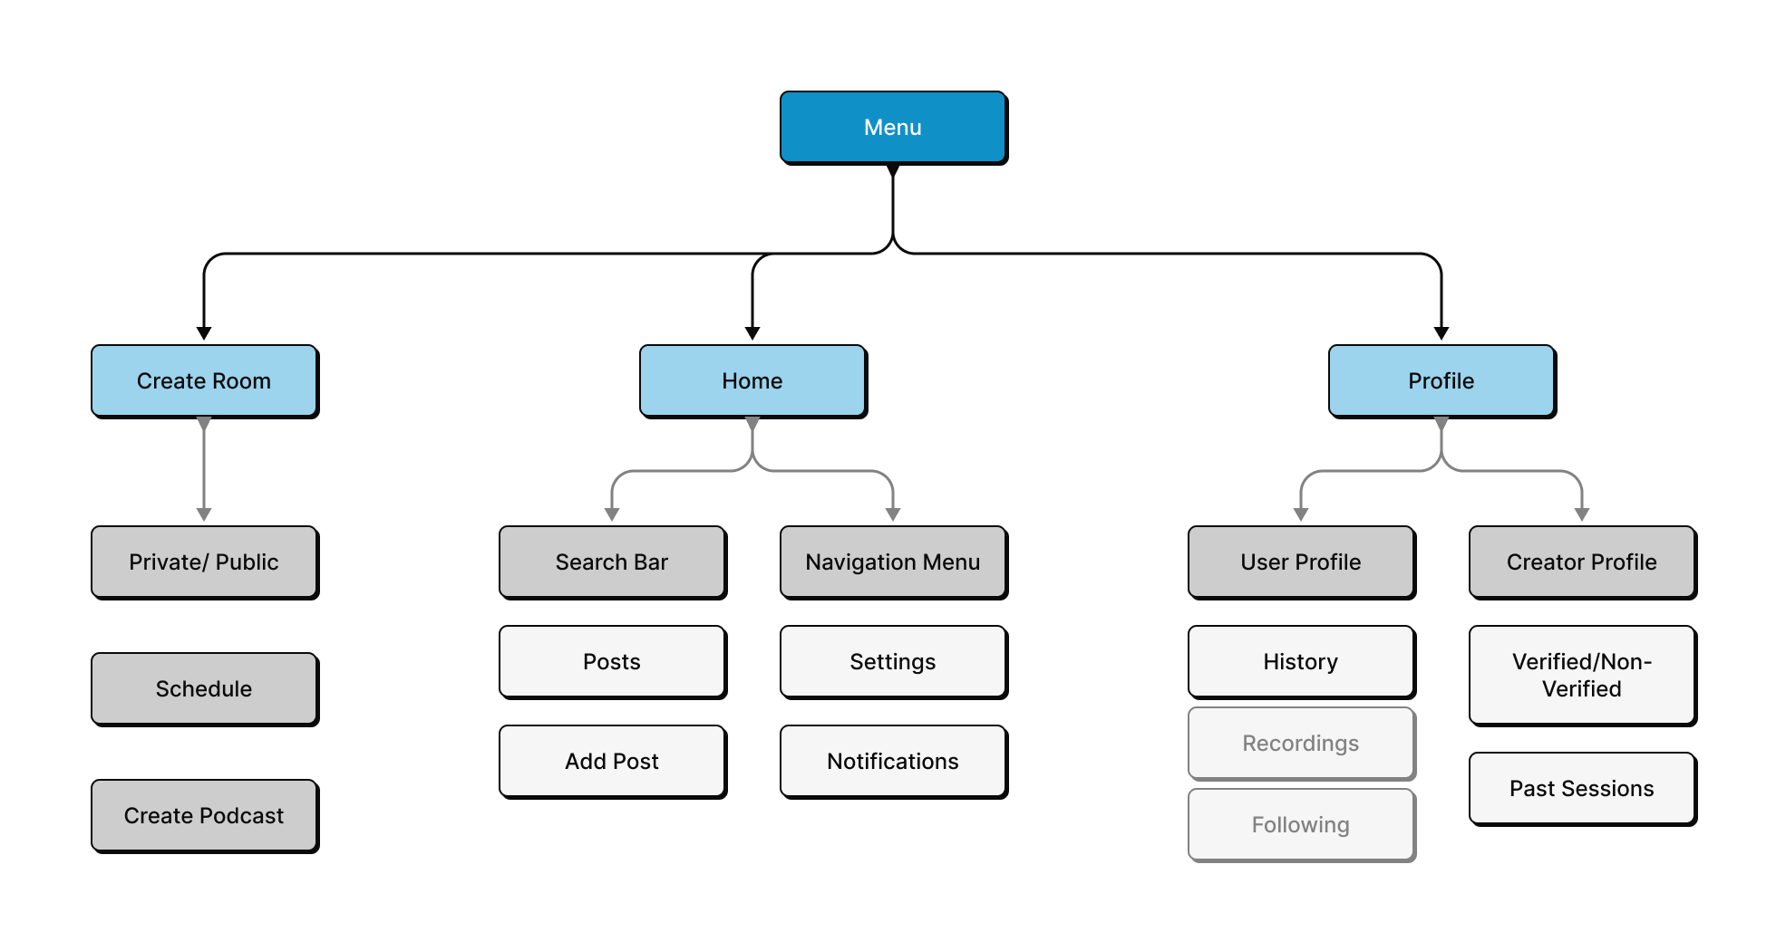

6.5 Inference:
We can conclude that if the prototype of the app goes into development and is again user tested between selected members and looked at its flaws and iterated upon them then the idea can be successful.

CHAPTER-7: CONCLUSIONS AND RECOMMENDATION

7.1 Outline:
To conclude the project is about the Social Audio app’s prototype which is to be hosted on a website which will be an introductory website for this app to user-test our prototype and can iterate on our designs.
7.2 Limitation/Constraints of the System:
As of now the limitation of this project is it cannot be forwarded into development as the prototype is not user tested and its only the first draft and no iterations have been performed. So we need too look for the reviews and the responses the users provides to our prototype make possible changes and then the design we go further into development.
7.3 Future Enhancements:
The future success of Hangout depends on how it can help users find content and enable engagements. The answer “through the use of user data”, but it might not be easy. Any social app solved many issues like to find and enable social interactions. We might end up making it a startup if we get good response about the idea.
7.4 Inference:
We can conclude that if the prototype of the app goes into development and is again user tested between selected members and looked at its flaws and iterated upon them then the idea can be successful.

RELATED WORK INVESTIGATION

*Discord*
- Discord is a lot like Skype but for gamers. Many gamers use it for audio, text, or video chat; with Discord also including the ability to build specific communities and groups on the platform.
- While you cannot browse for rooms to join, you can create your own and send out invitations for others to join you to chat. Discord also allows you to use the app in your browser and has less of a delay when using voice chat compared to other platforms.
- Discord Voice Chat allows you to make separate channels with different levels of permission for each user, so this prevents the chat rooms from becoming too crowded.
- *Twitter Spaces*
- Twitter Spaces is a live audio chat feature that the company started rolling out at the end of 2020. With the feature's beta, all Twitter users can join and listen in on a Space. If you are able to make a Space, be aware that anyone can join in and listen to your stream.
- That being said, you can decide who can speak in your Space when you are creating it. Meanwhile, only ten people are permitted to live stream in Twitter Spaces at one time.
- Once your Spaces session has been ended, just like Clubhouse, the conversations will no longer be available.

REFERENCES
- https://www.notion.so/PROJECT-HANGOUT-060a97b3d2c74b53b76370da3c22e019
- https://www.gartner.com/en/marketing/insights/daily-insights/the-future-is-podcasts
- https://uxplanet.org/introducing-voice-messaging-in-discord-a-ux-ui-case-study-e42e634cceb9
- https://www.theverge.com/2021/10/1/22704749/discord-ending-stage-discovery-channels

